To: City Executive Board

Date: 12 November 2015

Report of: Executive Director, Community Services

Title of Report: Northway and Marston Flood Alleviation Scheme

Summary and Recommendations

Purpose of report: To seek project approval for the Northway and Marston Flood Alleviation Scheme.

Key decision: Yes

Executive lead member: Cllr Ed Turner (Finance, Corporate Asset Management and Public Health) and Cllr John Tanner (Climate Change and Cleaner, Greener Oxford)

Policy Framework: Corporate Plan priorities- Cleaner, Greener Oxford, Vibrant and Sustainable Economy, Efficient and Effective Council, Stronger and Active Communities, Meeting Housing Needs.

Recommendation(s): That the City Executive Board resolves to:
- give project approval for the scheme;
- note the reduction in the need for Oxford City Council capital funding provision to deliver this project (a release of £1,268,000);
- give delegated authority to Executive Director, Community Services, in consultation with the Monitoring Officer and s151 Officer, to be able to enter into any necessary funding agreements to secure the external funding for the scheme; and
- recommend Council to resolve to include the additional budget of £928,000 for the Northway and Marston Flood Alleviation Scheme in the Capital Programme (£2,196,000 financed from external funding, £400,000 financed from Council capital).

Appendices

Appendix 1: Risk Register

Background:

- Northway and Marston are suburbs in Oxford, situated in the north east of Oxford. They are largely residential areas with a number of open spaces. The area has been subject to regular flooding events due to fluvial and surface water flooding originating from the Peasmoor Brook and Headington Hill Tributary.

- This project has arisen out of public concerns over a number of years about regular flooding of streets in Northway and New Marston. The issue came to a head in November 2005 when an article and photographs of flooding in Northway appeared in the Oxford Mail. While the precise cause of the periodic flooding was unknown and therefore the agency with responsibility for addressing the problem not identifiable, the City Council took the initiative as community leader.

- In 2011 Atkins (consulting Engineer) was commission by the Council to carry out a flood risk study to consider the origin, extent and severity of flooding in the area. There are currently no flood defences there and the conclusion of the study is that 110 private properties are affected by a storm with a 1% Annual Exceedence Probability (AEP) chance of occurring. Of the 110 properties there are 11 at risk of flooding from events as low as 50% AEP (1 in 2 years).

- The study considered a number of options which consisted of replacement of existing culverts with greater capacity culverts, pumping the flow around the affected area, creating floodwater storage areas in the catchment and flood warning and flood resilience measures. The report concluded that the option with the most favourable benefit/cost ratio is that of creating temporary flood storage areas in the local catchment- retaining torrential rain water runoff and releasing it slowly into the catchment.

- This option was taken forward and developed into a Project Appraisal Report (PAR) for submission to the Environmental Agency for Flood Defence Grant in Aid (FDGiA) funding. The bid was successful and the Council received the grant allocation letter from the Environment Agency in May 2015.

- A full time internal project manager has subsequently been appointed and a project board and project team mobilised. The Project Initiation Document has been taken to the CAMAC Board and approved for gateway 2; this allows procurement of the detailed design in order to move the project to delivery.

Project core benefit:

- There are 110 properties at risk during a 1 in 100 year flood event in the target area of this scheme. All 110 properties will received a benefit of reduced flood risk as a result of the measures installed by this project, with 91 properties being completely removed from the known risk of flooding.

Project objectives:

- To reduce the risk of flash flooding to 108 residential properties and 2 commercial properties in Northway and Marston by June 2017.
  - Reduce the risk to 53 properties from “very significant risk” (1 in 20 year event) to “moderate risk” (between 1 in 75 year and 1 in 200 year event).
  - Reduce the risk to 8 properties from “significant risk” (between 1 in 20 and 1 in 75 year event) to “moderate risk” (between 1 in 75 year and 1 in 200 year event).
  - Reduce the risk to 30 properties from “significant risk” (between 1 in 20 and 1 in 75 year event) to “low risk” (1 in 200 year event).
  - Improve standard of protection to all 110 properties at risk during a 1 in 100 year event with 91 residential properties being fully protected to a 1 in 75 year Standard of Protection (insurance break-point).
  - Avoid the economic risk of “doing nothing” of £319k per annum.

- To deliver ecological improvement to Northway Field, Peasmoor Brook and Court Place Farm Recreational area by June 2017.
  - Create 0.3 ha of amphibian/newt habitat at Peasmoor Brook and Court Place Farm Recreational ground.
  - Deliver amenity and biodiversity enhancement at Northway Field with dry wild flower grass mix and bulb planting of bund.
  - Completion of works to high standards that will enhance the local environment with this scheme being recognised as environmental exemplar project.

- To contribute to the enhancement of the recreational provision at Northway and Marston by June 2017.
  - Levelling Northway field for improved football pitch provision.
  - Creating wetland reserve along Peasmoor Brook on Court Place Farm recreation ground which will link with Court Place Farm Nature Reserve.

Project scope and exclusions:

- Scope

The project seeks to address the flood risk areas identified in the 2011 Flood Risk Study- namely properties on Stockley Road, Maltfield Road, Dents Close, Corpse Lane, Westland Drive, Saxon Way, and Borrowmead Road within Northway and Marston wards.
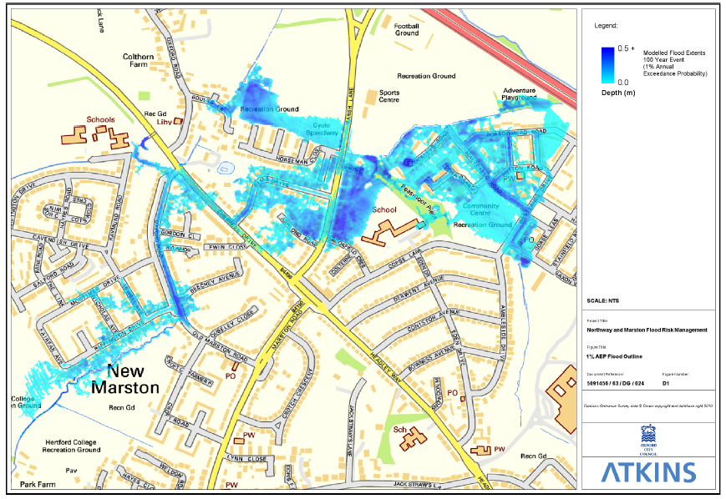
Figure 1: Flood reach outline in Northway and Marston area

In simple terms the risk of surface water flash flooding is caused by intense prolonged rainfall causing Headington Hill Culvert to breach and Peasmoor Brook to flood its banks.
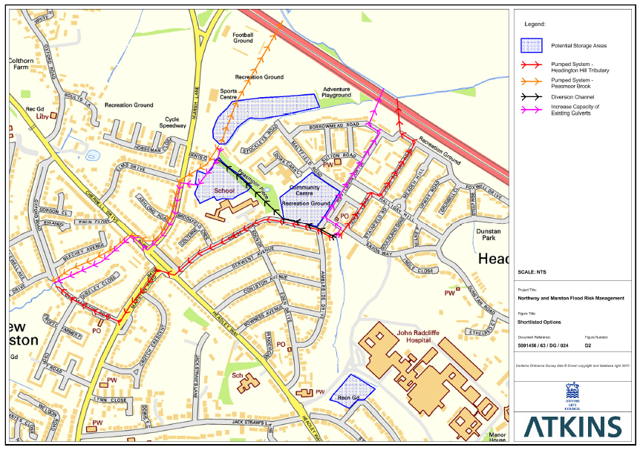
Figure 2: Flow direction within existing culverts and channels and location of options for temporary flood storage.
The scheme will predominantly use the mitigation method of temporary flood water storage to deliver the flood risk reduction benefits for residents and businesses in the area.
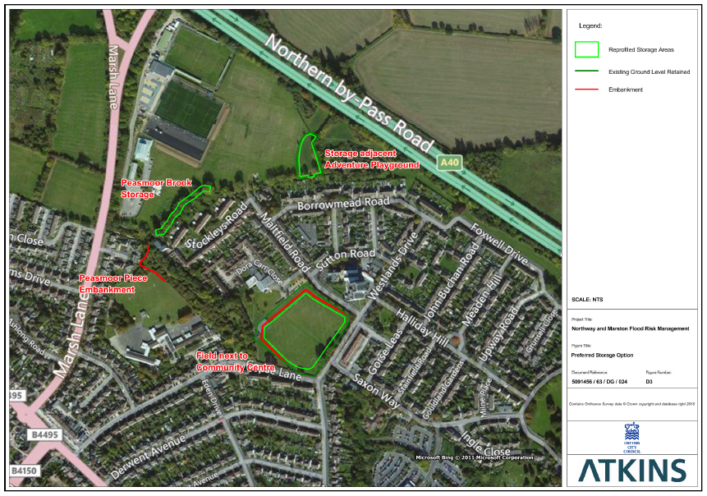
Figure 3: Outline of final scheme proposal including temporary flood storage at Northway Community Field and Court Place Farm (green outline) and natural embankments at Peasmoor Place and Northway Community Field.

- Exclusions
- Flooding occurring outside target streets and not originating from the Peasmoor Brook and Headington Hill Tributary.
- Reduction of residual risk after taking mitigation action e.g. a severe flood event that exceeds a flood management design standard.
- Emergency flood response within Northway and Marston.
- Flood mitigation measures within Greensquare Dora Close Redevelopment.
- Foul and sewerage flooding issues in Northway and New Marston.

Legal issues:

- The scheme will need to comply with the following statutory duties in its design and construction:
- Duty to consult and work with partners under the Flood and Water Management Act 2010.
- Requirements on river basin management and water quality under the Water Framework Directive 2000.
- Requirements to conserve European protected species under the Conservation of Habitats and Species Regulations 2010.
- Biodiversity duties under the Natural Environment and Rural Communities (NERC) Act 2006.
- Requirements under the Environmental Protection Act 1990 surrounding the use and disposal of waste, contaminated land and statutory nuisance (including noise).

- Oxford City Council hold a 99 year lease for Northway Community Field with Oxfordshire County Council as the landowner. Landowner consent will be required for any works carried out on Northway Community Field and revisions to the lease will need to be agreed to reflect changes to the site after project completion.

Financial issues:

- Initial estimates, which were made 18 months ago, put the costs of the main engineering elements of the scheme at £1,914,000. This estimate excludes the cost of wider project elements such as stakeholder engagement, landscaping and information/interpretation boards. More accurate project costs will become available once we have a detailed design for the scheme. However, given the information available and including allowance for inflation and contingencies, the project budget envelope for the scheme is £2,596,000.

- External funding has been successfully secured from the Environment Agency of £1,596,000 (Flood and Coastal Erosion Risk Management Grant in Aid [FCERM GiA] and Local Levy) and Oxfordshire Growth Board/ Oxfordshire Local Enterprise Partnership of £600,000 (Local Growth Fund 1).

- The securing of external funding has meant that the call on Oxford City Council capital funds can be reduced to £400,000 to cover the estimated remaining costs. When the scheme has been fully designed and costed, this internal capital allocation may need to be reviewed.

- The scheme is in the current capital programme at £1,668,000 which was anticipated to be fully funded by Council capital resources. The external funding and the revised estimate of scheme costs mean that £1,268,000 of this funding can be released to fund other capital schemes.

- By completing the flood alleviation scheme the Council will have removed the annual economic risk of “doing nothing” of £319,000 per annum.

Procurement:

- The following procurement strategy has been approved for delivery of the scheme:
- Designer and quality management:- Due to the value of money, and taking into consideration the Council’s Contract Rules, it is proposed that Atkins Ltd. be appointed as a direct award via Lot 16 of the Crown Commercial Services framework RM830 (Environment & Sustainability Advice Support & Delivery Services). The Council is legitimately able to commission a call-off contract off of this framework. The added benefit of using this framework is that the terms and conditions have already been established.
- Civil Engineer: - As the proposed works are well within the capability and capacity of Direct Services, the Council’s own Highways and Civil Engineering team will undertake the role of principal contractor. Once Direct Services have been commissioned any specialist works that cannot be undertaken directly by Direct Services will be sub-contracted with contractors working under Direct Services. Any appointments will follow a compliant process in accordance with the Council’s Contract Rules. Atkins will be retained as external quality manager to oversee the construction phase of the project.

Environmental impact:

- The scheme will result in the creation of habitat via the natural planting of bunds on Northway Community Field and the creation of a 0.3 hectare wetland reserve at Court Place Farm Recreation Ground. This will assist to improve these reaches to Good Ecological Status.

Level of risk:

- Please see the risk register Appendix 1.

- An Outline Risk Assessment has been carried out for the submission of the bid to the Environment Agency which has categorised the overall project risk as medium.

- An initial Designer’s Risk Assessment has been carried out with no unacceptable risks identified. A Public Safety Risk Assessment (PRSA) will be conducted during the detailed design phase.

- The main risks to the Council by giving project approval include:

  - Not securing external funding- mitigation: keeping to the grant conditions;
  - The scheme does not deliver the required outcomes- mitigation: careful design and construction management led by specialists in this field;
  - Cost over-runs- mitigation: significant build and client contingencies are included in the budget (circa 30%).

Equalities impact:

- This project has been reviewed for equalities impact and the conclusion is that this project has low impact on equalities and thus does not need to undertake an Equalities Impact Assessment.

- The flood reduction benefits delivered by this project may result in reduced insurance costs which could benefit lower income households. Equalities impact will be kept under review to ensure equality of access to the benefits from the scheme wherever possible (e.g. the pathways of the wetland reserve).

Public involvement:

- The communities of Northway and Marston were engaged extensively in 2012 in an attempt to gain an accurate picture of flood events in the area. The proposed scheme is well supported by local Members. We will be working with the local community over the next few months to set out proposals, understand and address any concerns around this project.

Conclusion:

- To conclude, it is recommended that the Council lead this project and for officers to ensure that it demonstrates value for money whilst being externally funded. It is recommended also that the project provides strong local benefit and is designed sympathetically providing enhancement to the local area.

Name and contact details of author:-
Name: Helen Vaughan-Evans
Job title: Northway and Marston Flood Scheme Project Manager
Service Area / Department: Environmental Sustainability / Communities Directorate
Tel: 01865 252156 e-mail: hvaughanevans@oxford.gov.uk

Background papers:

For more information please see http://www.oxford.gov.uk/nandmfloodproject

